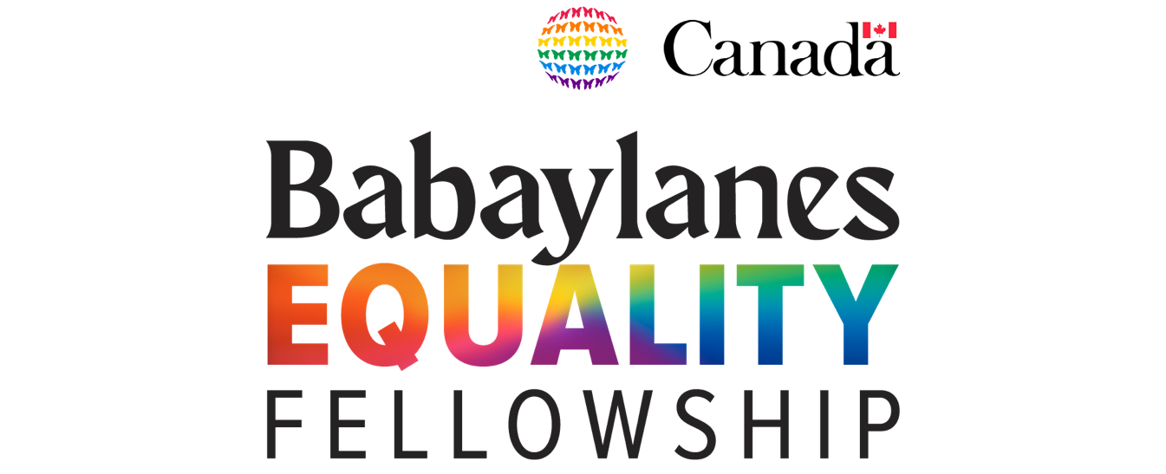

2022 Application Form

INSTRUCTIONS

Babaylanes Equality Fellowship requires a completed version of this form for the to guide the Selection Panel on evaluating your advocacies and work experience. Through this application form, the Selection Panel can determine applicants who are fit for the fellowship – which applicants need the trainings and which applicants are better suited for other programs.

Please accomplish this form by typing on the spaces below and clicking on the boxes that corresponds to your answer. If a question is not applicable, please put “N/A” on the space/s provided. Please make sure that you are able to complete the seven (7) parts of this application form. Incomplete and late submissions will not be entertained. After accomplishing this form, save this file (either as a .docx or a .pdf file) with this file naming convention:
BEF_2022_ApplicationForm_LastName_FirstName
(e.g. BEF_2022_ApplicationForm_DeLuna_Blaire)

Note that, you may send your application to babaylanesph@gmail.com only until 30 December 2021, 11:59PM. Please be reminded that your application should include:
- the accomplished 2022 Application Form (this form); and,
- a letter of cover letter addressed to Babaylanes President, Edwin M. Salonga.

If you have significant concerns about sharing sensitive information with us in any part of this application form, please contact us through info@babaylanes.org. Similarly, if you have difficulty completing this form (due to accessibility issues), let us know through the same email so we can process your application through a meeting or a phone call.

PART 1. Personal Information

Lived Last Name: | Type here. | Date of Birth  (YYYY-MM-DD): | Type here. | Age  (as of application): | Type here.
Lived First Name: | Type here. | Nationality: | Type here. | Assigned Sex at Birth: | Type here.
Address: | Type here. |  | Preferred Pronouns: | Type here.
Province/ Region: | Type here. | Ethnic Group (if any): |  | Type here.
Contact Details
Home Number: | Type here. | Email Address: |  | Type here.
Office Number: | Type here. | Number Used in Telegram/  Telegram Username: |  | Type here.
Mobile Number | Type here. | Other Contact Details: |  | Type here.

PART 2. English Communication Skills

Please indicate your level of comprehension of the English language by clicking the box corresponding to your answer:

Written  Excellent  Good  Fair  Poor | Spoken  Excellent  Good  Fair  Poor

PART 3. Educational Background

Highest Educational Attainment: | Type here.
School/College/University: | Type here.
Course/Degree Program (if any): | Type here.
Educational Achievements/ Awards (if any): | Type here.

PART 4. Professional Background

Current Occupation (Position/Title): | Type here. | Years of Work: | Type here.
Company Name: | Type here.
Previous Occupation (Position/Title): | Type here. | Years of Work: | Type here.
Company Name: | Type here.
Other Relevant Work Experience (if any):
Type here.
Written Works (if any):
Type here.

PART 5. Diversity Profile

Babaylanes Equality Fellowship champions diversity and representation in governance. With this, the fellowship aims to ensure diversity within the batch of this year’s fellows.Additionally, the program will be done via online platforms (i.e. Youtube, Zoom, Telegram). Hence, it is important that we are aware of your personal attributes that may affect your access or participation to the program.

Rest assured that this form will be kept in confidence and you are not required to disclose any information you are not comfortable sharing with us.

Do you identify as part of the LGBTQI community or as a person with diverse SOGIESC?
Yes
No
Rather not disclose
If yes, please indicate how you identify in terms of SOGIESC.
Type here.
Were you a member of an organization from the National LGBTQI Students Network?
Yes
No
Rather not disclose
If yes, what organization? |  | Type here.
Years as member: |  | Type here.

Do you have any disability?
Yes
No
Rather not disclose
If yes, please explain how Babaylanes can help improve accessibility of the program for you.
Type here.

Are you part of any ethnic minority group in the Philippines?
Yes
No
Rather not disclose
If yes, please indicate what group you belong to.
Type here.

Please indicate other issues that you may face in accessing online materials and having a synchronous class via Zoom.
Type here.

PART 6. Experience on LGBTQI Advocacy Work

What are your specific projects or engagements in LGBTQI advocacy or development work now or in the past? Please indicate the length of time you were involved in this engagement. Include here other development work/s you have done that may or may not be related to the LGBTQI Advocacy.
Type here.
Did you have any projects with Babaylanes or with Babaylanes partner organizations? If yes, please indicate them.
Type here.
What are other leadership trainings you have attended, if any?
Type here.
What are the notable leadership positions you’ve had both in the past and at present? Describe why you consider it notable.
Type here.
Have you had engagements in your local community (e.g. school, university, barangay, town, village, homeowner’s association)?
Type here.

Have you ever participated in or led a particular campaign or advocacy, local, national, or even international? Please indicate and quickly describe these campaigns.
Type here.
How do you see yourself 5-10 years from now?
Type here.
If accepted to the program, how do you think Babaylanes Equality Fellowship can benefit you?
Type here.

PART 7 – References

Please provide the contact details of character reference persons. Please note that these people will only be contacted for further verification of your application details.

Reference Person 1

Name: | Type here.
Organization: | Type here.
Position: | Type here.
Professional Relationship to the Applicant: | Type here.
Address: | Type here.
Contact Number: | Type here.
Email: | Type here.

Reference Person 2

Name: | Type here.
Organization: | Type here.
Position: | Type here.
Professional Relationship to the Applicant: | Type here.
Address: | Type here.
Contact Number: | Type here.
Email: | Type here.

-END OF APPLICATION FORM-

